

**Patient Name: Ashburn, Trenton**

**Date of Birth: 1978-04-29**

**Chart #: RAM22462**

**Referring Physician: Dr. Scott Rosa**

**Radiologist: Dr. David L. Harshfield, Jr. M.D., M.S.**

**Date of Exam: 2022-03-17**

**Previous Study: No comparison study available at the time of this interpretation.**

**Patient History: Headaches and neck pain.**

**Upright MRI C-SPINE with flexion, extension, Proton Density and Cine CSF flow data sets**

**TECHNIQUE:** To allow assessment of the functional and positional integrity of the spinal axis, in addition to standard sagittal and transverse data sets, multiple upright neutral (long axis), flexion and extension sagittal data sets are obtained. Thin section coronal, transverse, and sagittal proton density data sets are performed to optimize the visualization of the cervico-occipital junction ligamentous anatomy. Cine data set performed throughout range of motion of the cervical spine. Cine phase contrast CSF flow data sets performed to evaluate patency of the foramen magnum and document CSF flow throughout the cardiorespiratory cycle.

**FINDINGS:**

**ALIGNMENT:**

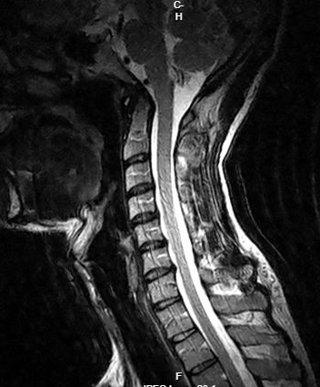

Adynamic/static configuration of spinal axis as manifestation of loss of the normal cervical lordosis.

**PATHOANATOMY:**

Multilevel discopathy involving the mid and lower cervical disc levels with level-by-level analysis provided in the body of this report.

Thickening of the adenoidal lymphoid pad with prominence of the mucosal lining along the palatine and lingual tonsils. Soft tissue narrowing of the nasopharynx and supraglottic airway is associated with snoring and sleep apnea as well as headaches and other neurological symptoms due to intermittent hypoxia.

**C0-C1:**

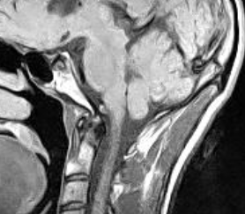

Encroachment by the cerebellar vermis and tonsils on the foramen magnum associated with capsulosynovial proliferative change of the atlanto-odontoid articulation. This constellation of findings constitutes so called 'Chiari 0' anatomy and has been associated with headaches and neurological symptoms associated with interference of normal CSF migration through the foramen magnum related to cardiac and respiratory activity. No evidence of wedging of the cerebellar vermis, cervico-medullary kinking, syringohydromyelia, cervico-occipital assimilation, or hydrocephalus to suggest high-grade Chiari malformation.

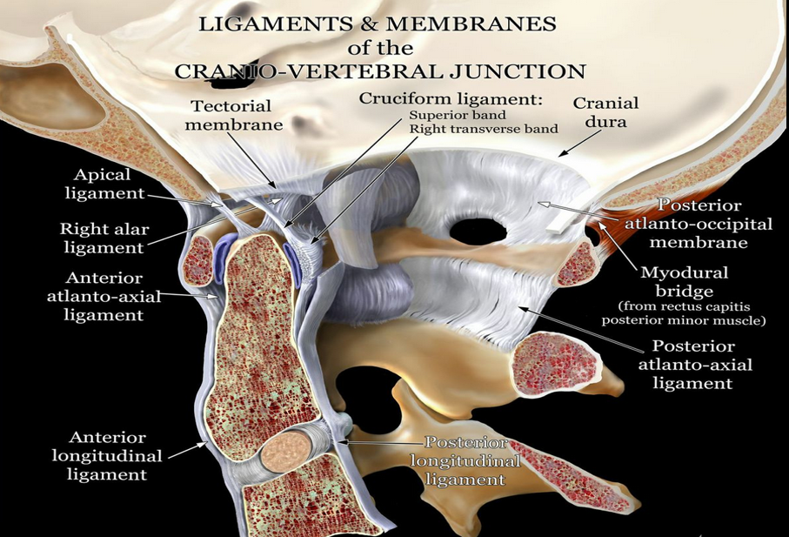 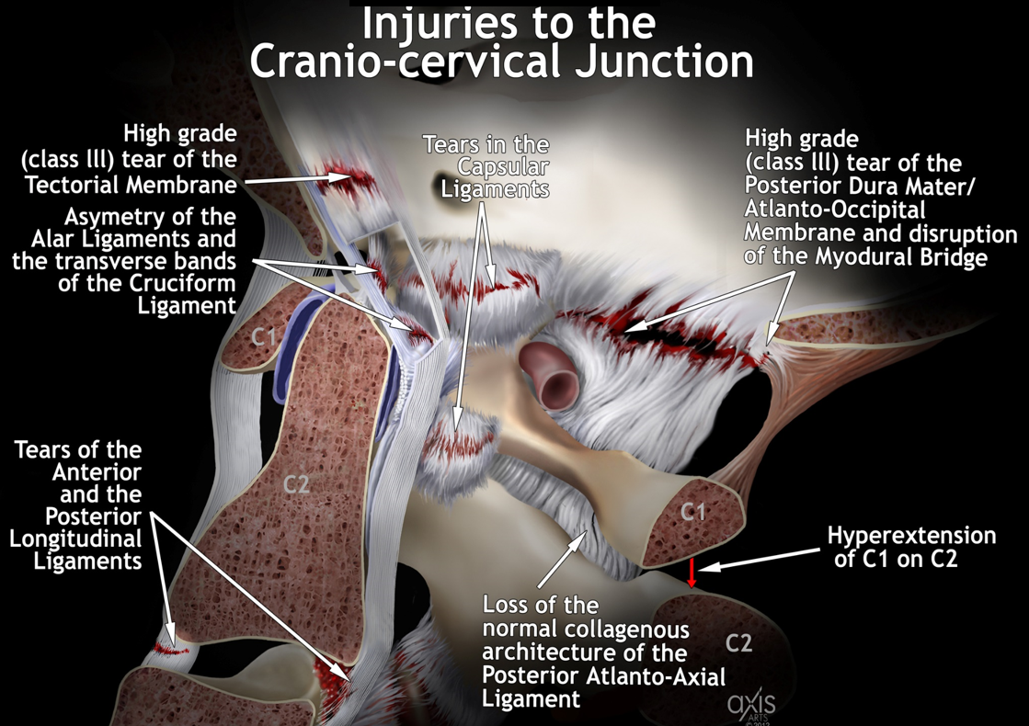

The upper middle image is a sagittal proton density image showing loss of the normal longitudinal collagenous architecture of the patient’s anterior dura mater/tectorial membrane (upper left image, patient’s sagittal proton density). Disruption of greater than 2/3rd’s the width of the tectorial membrane constitutes a high grade (Class III) lesion. Normal illustration of the craniocervical junction (upper middle image) and abnormal illustration of the craniocervical junction (upper right image) above.

Loss of the normal longitudinal collagenous architecture of the anterior longitudinal ligament (ALL). Disruption of greater than 2/3rd’s the width of the anterior longitudinal ligament constitutes a high grade (Class III) lesion. The anterior longitudinal ligament (C1,2) originates from the edge of the occipital foramen and consists of three layers of juxtaposed fibers that play an important role in the atlanto‐axial joint during the extension of the upper cervical spine. The anterior longitudinal ligament of the atlanto‐axial joint has a certain binding stress in the flexion and extension direction of the upper cervical spine, but the restraint effect is more obvious in the extension, especially after instability.

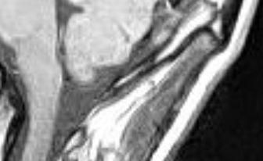

Loss of the normal longitudinal collagenous architecture of the posterior dura mater/ posterior atlanto-occipital membrane (PAOM). Disruption of greater than 2/3rd’s the width of the posterior atlanto-occipital membrane constitutes a high grade (Class III) lesion.

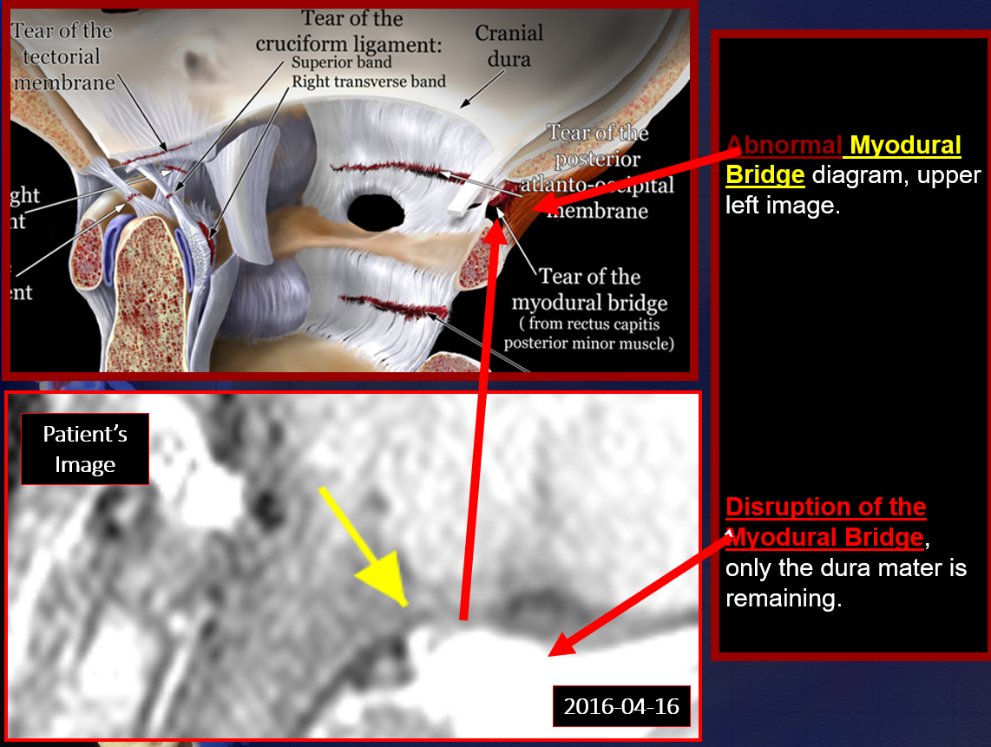

Abormal illustration (upper image) and sample abnormal MRI (lower image) above.

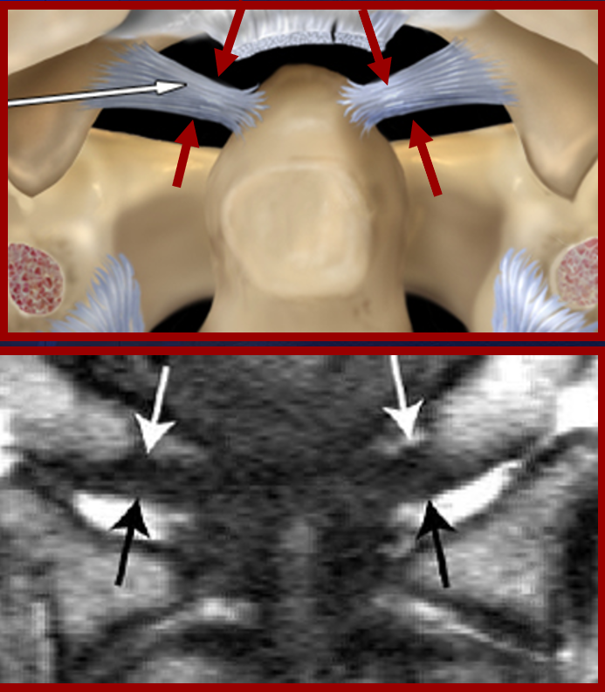

Asymmetry of the longitudinal collagenous architecture of the alar ligaments (above patient’s images). Normal illustration (upper image) and normal MRI of the Alar ligaments from the literature (lower image). The alar ligament extends from the tip of the odontoid process of C2 to the inside of the occipital condyles and the alar ligament mainly bears the tension during upper cervical spine extension. Its deformation and stress are greatly increased after instability of the upper cervical spine. The alar ligament is in a state of high stress, from 2.85 to 8.12 MPa, which indicates that the alar ligament plays an important role in maintaining the stability of the atlanto‐axial joint during extension. Due to its attachment to the tip of the odontoid process, this will inevitably lead to deviation of the odontoid process, which causes atlanto‐axial instability.

Asymmetric widening of the patient’s right lateral atlantodental interval (ADI) of the atlantoaxial joint (AAJ), serving as indirect evidence of disruption of the static stabilization mechanism of the craniocervical junction (CCJ).

Asymmetry of the transverse bands of the cruciform ligament. This is the strongest ligament in the entire spinal axis and typically abnormal increased signal indicates high grade disruption, as this ligament tears in an “all or none” manner. The cruciate ligament is located posterior to the odontoid process of C2 and consists of transverse and longitudinal fiber bundles. These ligaments play a key role in maintaining the stability of the atlanto‐axial joint (AAJ) during the flexion and extension of the upper cervical spine.

The cruciate ligament has a constraint effect on the flexion and extension of the atlantoaxial joint (AAJ) and when accompanied by the change of deformation and stress results in instability. With instability, the movement angle of atlanto‐axial joint (AAJ) increases significantly during flexion, but the atlanto‐occipital joint (AOJ) is not typically hypermobile. During extension, the movement angle of the atlanto‐axial joint and the atlanto‐occipital joint are not typically hypermobile. Combined with the stress analysis of the anterior longitudinal ligament, it is considered that this is due to the number of the limitation‐extension ligaments being higher and that its rigidity is greater. Therefore, when the cervical spine extends, the anterior longitudinal ligament produces a smaller shape variable, such that the change in angle is not obvious. In contrast, in the direction of flexion, the flavum ligament is mainly constraining the vertebrae, but its rigidity is low. Hence, the stress in the direction of flexion will produce greater deformation, resulting in a significant increase in the movement angle of the atlanto‐axial joint. This result also shows that frequent or prolonged flexion activities were more likely to cause damage to the upper cervical spine, leading to instability of the upper cervical spine. This can also partly explain why the large number of “phubbers” in our society are more likely to suffer from cervical spondylosis due to ‘text neck’.

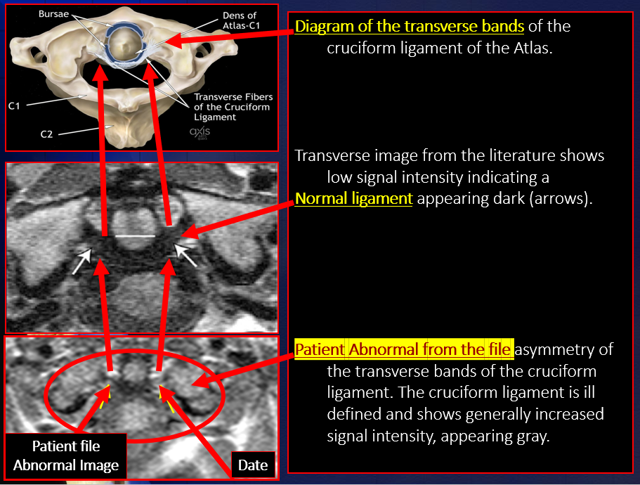

Normal illustration (upper image) and normal MRI (upper middle image) and abnormal MRI of the transverse bands of the cruciform ligament from the literature (lower image).

Asymmetric widening of the right lateral atlantodental interval (ADI) serving as indirect evidence of disruption of the static stabilization mechanism of the craniocervical junction.

**C1-2:**

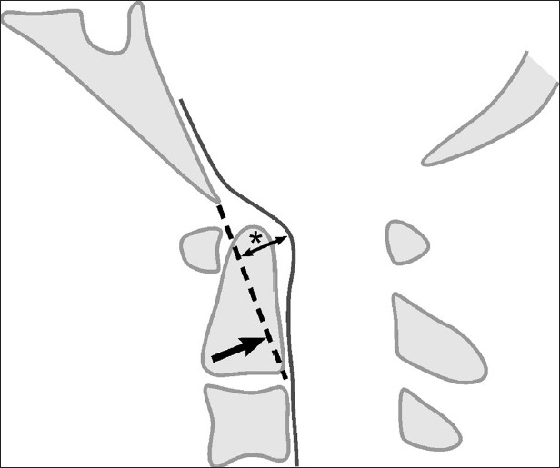

Hypertrophy of the atlantodental articulation with posterior capsulosynovial proliferation producing mild encroachment into the anteroposterior dimension of the central spinal canal below the foramen magnum without frank cord effacement or alteration of the contour of the cord. Grabb Oakes measurement of mm. Grabb-Oakes measurement: the perpendicular distance (*) from the BpC2 line (Basion to posterior inferior C2 body) to the dura. A value greater than or equal to 9 mm indicates ventral brainstem compression.

Hyperextension of C1 on C2, with close approximation of the posterior ring of C1 with the spinous process of C2.

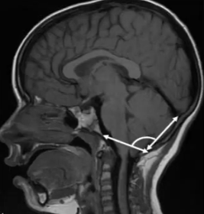

The angle of the occipital protuberance is within normal limits (upper left image is the patietn’s proton density sagital image and the upper right image illustrates a normal angle, with greater than 130 degrees being within normal limits).

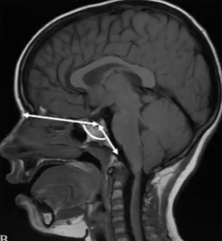

Skull base angle is within normal limits (upper left image is the patietn’s proton density sagital image and the upper right image illustrates a normal angle with less than 140 degrees being within normal limits)

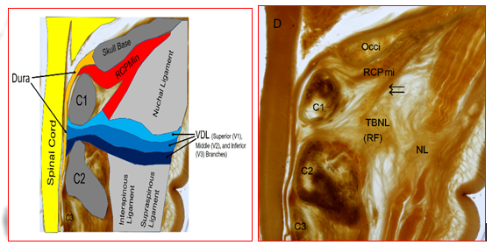

Loss of the normal collagenous architecture of the posterior atlantoaxial ligament (upper left image, patient’s sagittal proton density image). This fascial structure normally arises from the tissue of the posterior border of the nuchal ligament and projects anterior and superior to enter the atlantoaxial interspace and insert on the dura mater (vertebrodural ligament- VDL). The VDL firmly links the posterior aspect of cervical dura mater to the rear of the atlas-axis and the nuchal region. The movements of the head and neck affect the shape of the cervical dural sleeve via the VDL, and the muscles directly associated with the cervical dural sleeve, in the suboccipital region, work as a pump providing an important force required to move the CSF in the spinal canal.

Loss of the normal anatomic relationship of C1 and C2, consistent with atlantoaxial rotatory instability/insufficiency.

In addition to compression of the internal jugular vein, there is also potential compression of the adjacent three important cranial nerves (IX, X, and XI- glossopharyngeal, Vagus, and accessory nerves, respectively) which travel down from the cranium through the jugular foramen and lie immediately anterior to the transverse processes of the Atlas. The Vagus is the largest of the 12 cranial nerves and trauma to the craniocervical junction (CCJ) can result in a Vagopathy, resulting in a multitude of potentially confusing and seemingly disparate symptoms, deemed CCJ syndrome (CCJS).

It is exactly the anatomy of the neurovascular structures traversing this narrow passage that has heretofore been either unknown or misunderstood by traditional medicine, manifested as mispositioning of the Atlas causing compression/pressure on the above-mentioned cranial nerves triggering pain and other unusual symptoms that can be difficult to explain without this understanding.

Asymmetric widening of the right lateral atlantodental interval (ADI) serving as indirect evidence of disruption of the static stabilization mechanism of the craniocervical junction.

C2 nerve rootlet provides sensory to the lateral occiput and submandibular area; motor, same as C1 (motor to head and neck extensors, infrahyoid, rectus capitis anterior and lateral, and longus capitis) plus longus colli.

**Nomenclature and Classification of Disc Pathology** 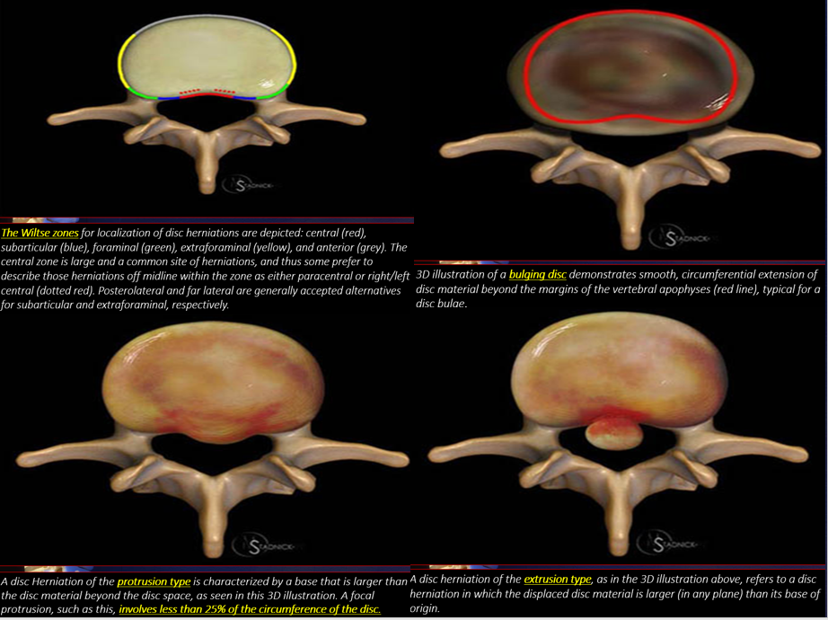

**C2-3:**

Normal intradiscal T2 signal and concave posterior disc margin, without compressive discopathy, central canal stenosis, foraminal stenosis, or neural effacement.

Clinically significant encroachment upon the C3 nerve rootlet may present with posterior neck numbness and pain radiating to the mastoid and ear. C3 provides sensory to lateral occiput and lateral neck, overlapping C2 area; motor to head and neck extensors, infrahyoid, longus capitis, longus colli, levator scapulae, scaleni, and trapezius.

**C3-4:**

Decreased intradiscal T2 signal. Shallow posterior disk placement, with moderate biforaminal stenosis related to symmetric facet hypertrophy.

Clinically significant encroachment upon the C4 nerve rootlet provides sensory to the lower lateral neck and medial shoulder area; motor to head and neck extensors, longus coli, levator scapulae, scaleni, trapezius, and diaphragm.

**C4-5:**

Normal intradiscal T2 signal and concave posterior disc margin, with moderate biforaminal stenosis related to symmetric facet hypertrophy.

Clinically significant encroachment upon the C5 nerve rootlet may present with diminished deltoid and pectoralis reflexes, motor weakness of the deltoid muscle, as well as para and hypoesthesia of the shoulder. C5 provides sensory to the clavicle level and lateral arm (axillary nerve); motor to deltoid, biceps; biceps tendon reflex.

**C5-6:**

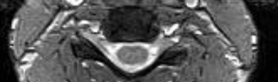

Normal intradiscal T2 signal. Shallow posterior disk placement, without compressive discopathy, central canal stenosis, foraminal stenosis, or neural effacement.

Clinically significant encroachment upon the C6 nerve rootlet may present with diminished biceps and brachioradialis reflexes, motor weakness to forearm flexion, and para and hypoesthesia of the upper arm, thumb, and radial forearm. C6 provides sensory to the lateral forearm, thumb, index and half of 2nd finger (sensory branches of musculocutaneous nerve); motor to biceps, wrist extensors; brachioradialis tendon reflex.

**C6-7:**

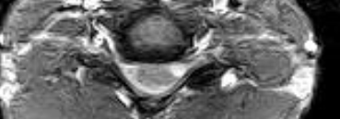

Decreased intradiscal T2 signal and rightward posterior disk herniation of the broad-based protrusion type, with moderate biforaminal narrowing related to uncovertebral joint and facet hypertrophy, greater on the right.

Clinically significant encroachment upon the C7 nerve rootlet may present with decreased triceps reflexes, decreased motor function to forearm extension (wrist drop), and decreased sensation in fingertips 2 and 3 and all fingertips. C7 provides sensory to the second finger; motor to wrist flexors, finger extensors, triceps; triceps tendon reflex.

**C7-T1:**

Normal intradiscal T2 signal and concave posterior disc margin, without compressive discopathy, central canal stenosis, foraminal stenosis, or neural effacement.

Clinically significant encroachment upon the C8 nerve rootlet may present with decreased finger jerk reflexes, motor weakness of the intrinsic hand muscles, and decreased sensation of fingers 4 and 5. C8 provides sensory to the medial forearm (medial antebrachial nerve), ring and little fingers (ulnar nerve); motor to finger flexors, interossei; no reflex applicable.

**T1-2, T2-3, T3-4, and T4-5:**

Normal intradiscal T2 signal and concave posterior disc margin, without compressive discopathy, central canal stenosis, foraminal stenosis, or neural effacement.

**PATHOKINESIOLOGY:**

**Flexion:**

**Instability:**

Anterolisthesis of C3 on C4 as manifestation of insufficiency of the posterior longitudinal ligament (PLL).

Widening of the posterior disk space heights at the C3-4 and C4-5 levels consistent with insufficiency of the posterior longitudinal ligament (PLL).

Widening of the interspinous intervals at the C3-4 and C4-5 levels as a manifestation of insufficiency of the capsular and interspinous ligamentous complexes.

**Rigidity:**

The cervicothoracic discovertebral segments demonstrate paradoxical lordosis to flexion stress. Paradoxical lordosis is considered a guarding mechanism that can serve as indirect evidence of muscle spasm/soft tissue injury.

Decreased mobility of the C1-2 level manifested as fixed hyperextension of C1 on C2 throughout range of motion.

Relative immobility of the discovertebral segments of the entire cervical spinal axis, including the cervicothoracic junction to flexion stress.

**Extension:**

**Instability:**

The cervicothoracic discovertebral segments demonstrate no appreciable retrolisthesis to extension stress.

Retrolisthesis of C2 on C3, C3 on C4, C4 on C5, C5 on C6 and C6 on C7 to extension stress.

Widening of the anterior disk space heights at the C3-4, C4-5 and C5-6 levels consistent with insufficiency of the anterior longitudinal ligament (ALL).

Position dependent exacerbation of the disk displacements.

**Rigidity:**

Relative immobility of the discovertebral segments of the entire cervical spinal axis to extension stress.

**Kinematic Motion Study of C spine:**

Relative immobility of the discovertebral segments of the entire cervical spinal axis, including the cervicothoracic junction throughout range of motion.

**Brain:**

Symmetric ventriculosulcal system for age.

Distention of the CSF spaces in the Meckel cave regions, accompanied by dural ectasia of the optic nerve sheaths, both findings having been directly correlated with intracranial pressure.

Mild uniform periventricular T2 and FLAIR hyperintensity noted, without extensive deep or subcortical white matter ischemic gliotic changes, and without accompanying abnormal signal involving the brain or brainstem.

Vertebrobasilar dolichoectatic (VBD) noted. Evidence of vascular loops in the distribution of the exit root zones of adjacent nerves, which can predispose to neurovascular conflict by artery or vein due to juxta position of the nerves and vessels. Otherwise, normal expected flow void signal seen within the major contributors to and tributaries of the circle of Willis as well as the dominant venous outflow tracts.

The pituitary gland is reduced in size consistent with so-called “partial empty sella turcica”. Empty sella is a condition in which the pituitary gland shrinks or gets flattened while Partial empty sella (as in this patient) is consistent with a portion of the pituitary gland is visible on MRI scan. The reported prevalence of primary empty sella in general population is 8–35 %. The incidence is more in females, the ratio being 5:1. It is generally found in middle aged women who are obese and hypertensive.

Empty sella syndrome is a radiological finding where spinal fluid is found within the sella, the space created for the pituitary. Empty sella syndrome is divided into two categories based on degree:

* Partial empty sella syndrome – when less than 50% of the sella is filled with spinal fluid and the pituitary gland thickness ranges from 3 to 7 mm, with 7 mm being the lower limit of normal thickness.
* Total empty sella syndrome – when more than 50% of the sella is filled with spinal fluid and the pituitary gland thickness is less than or equal to 2 mm.

The pituitary gland is partitioned from brain by the sellar diaphragm and drained by emissary veins in communication with the extracranial compartment. The “empty sella” appearance has been historically attributed to a patulous diaphragma sella, usually from transient enlargement of the pituitary stalk during pregnancy, allowing CSF pulsation from the suprasellar subarachnoid space. And the pituitary gland is also susceptible to compression by raised intracranial pressure. Although fluids and fluid-filled tissues are essentially incompressible, the exodus of fluid from the sella turcica via the emissary veins and cavernous sinuses allows for flattening of an otherwise incompressible pituitary gland. There may or may not be functional impairment of the pituitary gland, however, laboratory correlation is performed as clinically indicated. Involution of the pituitary gland with aging has been considered a normal phenomenon, and the theory that involution coupled with intrasellar herniation of cerebral spinal fluid throughout an incompetent diaphragma sella leads to the appearance of anterior partial empty sella, encountered on many MRI studies particularly in women over the age of 50. However, research with NASA has revealed that this change in the pituitary gland and its connection to the brain is also found in astronauts during and after space travel, thought to be due to idiopathic intracranial hypertension. And recent our studies reveal “empty sella” also occurs concomitantly in patients with cerebellar tonsillar ectopia, which is associated with increased intracranial pressure due to disturbance of CSF homeostasis.

The pituitary can be small due to sequela of trauma, with measurable alterations of clinical Involvement of TBI on Pituitary Function tests. Traumatic brain injury (TBI) may be associated with impairment of pituitary hormone secretion, which may contribute to long-term physical, cognitive, and psychological disability. The first study describing pituitary damage as a potential outcome of TBI was published in 1918 as observed in a patient with a skull base fracture showing pituitary necrosis at autopsy. Clinical awareness of hypopituitarism expanded in the last 15 years following observations of high incidence of neuroendocrine alterations due to moderate and severe TBI. Diagnosis of hormonal deficiencies is insidious, and symptoms can be non-specific and/or potentially attributed to post-traumatic stress disorder (PTSD) (i.e., fatigue, attention impairment, depression, apathy, anorexia). Keeping this assorted clinical context in mind, it is important to underline those delays in diagnostic processes and late initiation of appropriate replacement therapy for hypopituitarism are associated with increased morbidity and mortality.

Post-TBI hypopituitarism is characterized by a heterogeneous clinical spectrum that ranges from mild and non-specific symptoms to urgent conditions requiring emergency admission, including water and salt imbalance, adrenal crisis, and severe hypoglycemia. Clinical manifestations depend on the number and type of pituitary axes involved, the severity of hormone deficiency, and time elapsing between hypopituitarism onset and the actual diagnosis and treatment. No relationship has been detected about pituitary dysfunction and 1) years since TBI, 2) type of injury, and 3) outcome from TBI. Overall, growth hormone deficiency (GHD), ACTH insufficiency, and gonadotropin deficiency are the most frequent abnormalities observed in post-TBI patients. The prevalence of these hormonal alterations varies according to the different phases of the trauma: Acute phase (1–14 days post event) and chronic phase (3–6 months post event). Each phase is characterized by specific hormonal imbalance.

**Cine CSF flow study**

**Pre-Adjustment**

**Sagittal**

**Systole Diastole**

**Transverse**

**Systole Diastole**

**Post Adjustment**

**Sagittal**

**Systole Diastole**

**Transverse**

**Systole Diastole**

The cerebellar tonsillar ectopia is producing interference with normal CSF migration through the foramen magnum related to cardiac activity and respiratory variation prior to adjustment of the first cervical vertebra (C1). After adjustment of C1, there is much more uniform CSF flow through the foramen magnum as well as improved blood flow through the straight sinus draining the “deep” system of the encephalic venous outflow tract.

**IMPRESSION:**

**ALIGNMENT:**

Adynamic/static configuration of spinal axis as manifestation of loss of the normal cervical lordosis.

**PATHOANATOMY:**

Multilevel spondyloarthropathy involving the mid and lower cervical disc levels with level-by-level analysis provided in the body of this report.

Attenuation of several of the key elements of the ligamentous and membranous static stabilization mechanism of the cervico-occipital junction, the constellation of findings consistent with sequela of hyperextension/flexion/hypermobility stress of the craniovertebral junction.

The ligamentous integrity is the key element of impacting the stability of the upper cervical spine injuries.

* Upper cervical spine stability mainly depends on the stability of the atlanto‐occipital and the atlanto‐axial joint.
* Loss of the normal anatomic relationship of C1 and C2, consistent with atlantoaxial rotatory instability/insufficiency.
* The transverse ligament serves as the most crucial element in determining the stability of occipital condyle (C0) and atlas (C1) as well as atlanto-axial joint (AAJ- C2-3).
* The integrity of anterior longitudinal ligament, disc, and facet joint attributes to the stability of the axis (C2).
* The integrity of tectorial membrane and alar ligaments determines the stability of atlanto-occipital joint (AOJ).

In addition to compression of the internal jugular veins, there is also potential compression of the adjacent three important cranial nerves.

Encroachment by the cerebellar tonsils on the foramen magnum without high-grade Chiari malformation (CM).

CM is defined as a descent of the cerebellar tonsil into the upper cervical canal. Several pathogenic mechanisms have been proposed, divided mainly into:

* A volumetric disproportion between the posterior fossa and its contents (reduced embryologic development of the skull base),
* Hemodynamic/cerebrospinal fluid dynamic alterations resulting in increased intracranial pressure,
* Mass effect within the posterior fossa (e.g., tumors), and
* Low intraspinal pressure due to craniospinal intrathecal pressure imbalance.
* Atlantoaxial instability is suspected to contribute to Chiari malformation.

The pituitary gland is reduced in size consistent with so-called “partial empty sella turcica”.

No evidence of abnormal occipital protuberance angle or abnormal skull base angle.

**PATHOKINESIOLOGY:**

**Instability:**

1. Anterolisthesis of C3 on C4 as manifestation of insufficiency of the posterior longitudinal ligament (PLL).
2. Widening of the posterior disk space heights at the C3-4 and C4-5 levels consistent with insufficiency of the posterior longitudinal ligament (PLL).
3. Widening of the interspinous intervals at the C3-4 and C4-5 levels as a manifestation of insufficiency of the capsular and interspinous ligamentous complexes.
4. The cervicothoracic discovertebral segments demonstrate no appreciable retrolisthesis to extension stress.
5. Retrolisthesis of C2 on C3, C3 on C4, C4 on C5, C5 on C6 and C6 on C7 to extension stress.
6. Widening of the anterior disk space heights at the C3-4, C4-5 and C5-6 levels consistent with insufficiency of the anterior longitudinal ligament (ALL).
7. Position dependent exacerbation of the disk displacements.

**Rigidity:**

1. The cervicothoracic discovertebral segments demonstrate paradoxical lordosis to flexion stress. Paradoxical lordosis is considered a guarding mechanism that can serve as indirect evidence of muscle spasm/soft tissue injury.
2. Decreased mobility of the C1-2 level, manifested as fixed hyperextension of C1 on C2 throughout range of motion.
3. Relative immobility of the discovertebral segments of the entire cervical spinal axis, including the cervicothoracic junction, to flexion stress.
4. Relative immobility of the discovertebral segments of the entire cervical spinal axis, including the cervicothoracic junction, to extension stress.

**Kinematic Motion Study of C spine:**

Relative immobility of the discovertebral segments of the entire cervical spinal axis, including the cervicothoracic junction throughout range of motion.

**Brain:**

**Cine CSF flow study**

The cerebellar tonsillar ectopia is producing interference with normal CSF migration through the foramen magnum related to cardiac activity and respiratory variation prior to adjustment of the first cervical vertebra (C1). After adjustment of C1, there is much more uniform CSF flow through the foramen magnum as well as improved blood flow through the straight sinus draining the “deep” system of the encephalic venous outflow tract.

The cerebellar tonsillar ectopia is producing interference with normal CSF migration through the foramen magnum related to cardiac activity and respiratory variation.



Dr. David L. Harshfield, Jr. M.D., M.S.

Board Certified Radiologist with multispecialty training in MSK, Ultrasound, Interventional Radiology and Cellular Medicine Therapy

**From the literature-**

**Depicting and understanding the anatomy and pathoantomy of the Craniocervical Junction (CCJ)**

